# Lab 5

# **Create a Decision Tree to represent the person preference for buying a car by creating your own scenario.**

## **Objective :**

* To understand how decision tree is made.
* To know how decision is works.

## **Theory :**

A decision tree is one of the most powerful tools of supervised learning algorithms used for both classification and regression tasks. It builds a flowchart-like tree structure where each internal node denotes a test on an attribute, each branch represents an outcome of the test, and each leaf node (terminal node) holds a class label. It is constructed by recursively splitting the training data into subsets based on the values of the attributes until a stopping criterion is met, such as the maximum depth of the tree or the minimum number of samples required to split a node.

To create a decision tree for given scenario we can consider different factors like budget, safety , comfort , color etc. Further we discuss how these factors are implemented in decision tree; here we can implement decision factors like in flowchart structure where internal nodes denotes the rules and leaf nodes is result. Its makes many possible subsets of scenario until the best outcome is obtained. At above scenario the first factors may be budget where people decides how much they can afford then safety , comfort colors are comes on the way to make best decision .

The main factors which can be effective to make decision tree are noted below:

* Budgets
* Safety
* Comfort
* Color
* Milage

**Output :**

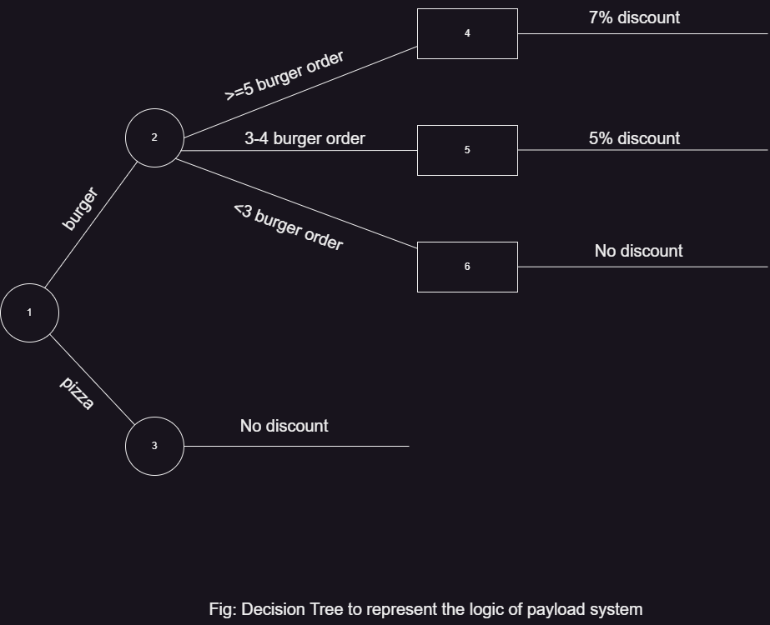

## **Conclusion:**

The decision tree is successfully constructed by applying different scenario of buyer. Which help the buyer to make a clear decision according to their needs.